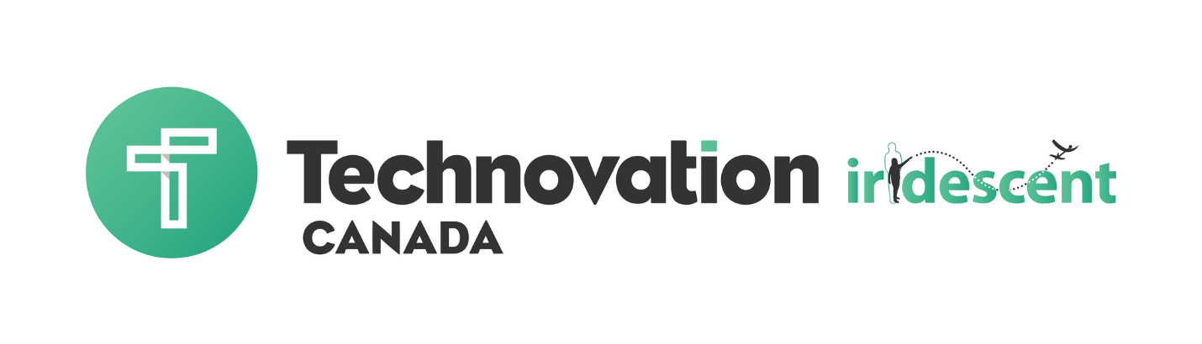

Student Workbook

Ottawa 2018

Table of Contents

1. Brainstorm Community Problems 3
2. Create a Problem Statement 10
3. Create a Mission Statement 12
Code 2: Data and Variables 14
4. Consumer and Competitor Research 15
Code 3: Logic, Loops, and Conditionals 21
5. Identify Your Brand 23
Code 4: Using Mobile Features & Connecting to the Web 27
6. Business Model 28
7. Create Visuals and a Logo 33
8. Create a Marketing Plan 36
9. Create a Pitch Story & Video 39
10. UX Design and Paper Prototyping 42
11. Business Plan Checklist 50
Submission Guidelines 51

Brainstorm Community Problems

So how do you want to use code to change the world? Here are some ideas and activities to help you get started!

- If you could use code to create anything, what would you create?
- What is a problem in your community that you would like to address?

Activity: Brainstorming Community Research

Community Documenting Worksheet

You will need:

- Pen or pencil
- Digital camera or cellphone with camera (optional but good to have)
- Clipboard (optional but good to have)

What You’ll Do:
- Go to the area your team has chosen to observe. It is advised that you go with an adult chaperone or your mentor. If you have the worksheet, you can use that to record your responses. Otherwise, write down where the area is on a piece of paper. Be specific. (As an alternative, you can gather and read articles about the area and the problem that you are interested in working on.)
- Slowly walk around the area once and make a note or take pictures of the major structures (e.g. churches, stores, buildings, schools).
- Walk the area again, this time looking for less obvious things. Some examples: a community garden, a row of trees, a vacant lot, billboards. If possible, use your cellphone or camera to take pictures. As you observe this time, write down not only what you see, but also what you hear, smell, or feel.
- When you return inside, respond to the following questions:
- What surprised you the most about the community?
- Can you see any problems that are affecting the community? If so, who is it affecting and how?
- What do you think this community needs to help solve the problem/s?
- Who would be responsible for making that change and how?
- How might the community needs be solved by technology?

Pick a block or area in your neighborhood. Write down where it is.

______________________________________________________________________________

Slowly walk around the block once and make a note of or take pictures of the major structures (e.g. churches, stores, buildings, schools).

______________________________________________________________________________

______________________________________________________________________________

______________________________________________________________________________

______________________________________________________________________________

______________________________________________________________________________

______________________________________________________________________________

______________________________________________________________________________

______________________________________________________________________________

______________________________________________________________________________

______________________________________________________________________________
Walk the area again, this time looking for less obvious things. Some examples: a well-kept yard on a street of concrete, a community garden, a row of trees, a vacant lot, billboards. If possible, use your cellphone or camera to take pictures.

As you observe this time, write down not only what you see, but also what you hear, smell, or feel.

______________________________________________________________________________

______________________________________________________________________________

______________________________________________________________________________

______________________________________________________________________________

______________________________________________________________________________

When you get back, respond to the following questions:

1. What surprised you the most about the community?

______________________________________________________________________________

______________________________________________________________________________

______________________________________________________________________________

______________________________________________________________________________

______________________________________________________________________________

2. Can you see any problems that are affecting the community? If so, who is it affecting and how?

______________________________________________________________________________

______________________________________________________________________________

______________________________________________________________________________

______________________________________________________________________________

______________________________________________________________________________

3. What do you think this community needs to help solve that problem?

_____________________________________________________________________________

_____________________________________________________________________________

_____________________________________________________________________________

_____________________________________________________________________________

_____________________________________________________________________________

4. Who would be responsible for making that change and how?

______________________________________________________________________________

______________________________________________________________________________

______________________________________________________________________________

______________________________________________________________________________

______________________________________________________________________________

5. How might the community needs be solved by technology?

______________________________________________________________________________

______________________________________________________________________________

______________________________________________________________________________

______________________________________________________________________________

______________________________________________________________________________

______________________________________________________________________________

______________________________________________________________________________

______________________________________________________________________________

Discuss what some of the common things that your team noticed were. Were there any surprises? What were some of the problems that you noticed in the community? Do you have pictures that can help illustrate your points? Does your team feel strongly about any of these issues? Why? What would your next steps be to gather more information? Can you talk to people in your social network or community to help locate and understand common problems?
There are other ways to gather information. Here is another activity you can do to help visualize the community in another way.

Activity: Brainstorming community descriptions

Our Community A to Z

Another way to visualize communities is by the brainstorming words that describe them. After you discuss your observations from the community documenting activity, you can try this too. It’s fun!

What you will need:
- Write a set of letters A-Z (or the letters of your alphabet) on a chalkboard or a whiteboard for each team member. You could do this on a piece of paper instead, one piece of paper per person.
- A marker for each person
What you will do:
- Each team member should write one word that describes the community for as many letters of the alphabet as possible, as fast as she can. To make it more fun, you can make it a competition. It is good not to overthink this as it is meant to be spontaneous.
- Afterwards, everyone should take a look at all the words that came out of this activity and discuss them. Are there any commonalities? Any surprises? What kind of new information came out of this activity that didn’t happen with the physical observation?

Now that you have gathered evidence of themes or issues in your community, you and your team should talk about which of the issues are important. Then, you can decide which one to work on. Before this conversation takes place though, let’s take a look at the themes that Technovation is asking participants to develop solutions for this year, as this could influence your decision.

Activity: Decide on a Problem

Now that you have discovered and gathered evidence of the issues in your community and learned about the 2017 Technovation themes, it is time to choose a problem your team would like to work on for the project.

What you will need:

- Post-its or paper
- Pens or markers

What you will do:
- Have everyone think about the community needs and write down the problems they are interested in solving on a post-it, a piece of paper, or a notecard on ideaboardz.com. Put one idea on each post-it. No idea is right or wrong.
  - For each problem, include two sentences. Write one about why the problem is important and what the evidence is for this.Write the second one about whom the problem affects and how.
- After about 15 minutes, everyone should bring their post-its up to the wall and look at them as a group.
- Discuss whether there are any patterns. Here are some important questions to answer:
  - Is there any overlap in interest?
  - Can any of the ideas be organized into the Technovation 2017 themes?
  - Are the problems so wide in scope that they will not be easily addressed by an app? If so, can they be broken down into smaller problems?
    - Keep in mind that the problem will need to be addressed by a mobile app, so you will need to make good use of the features that mobile technology has to offer such as GPS, camera, accelerometer, or voice recognition. This will be discussed further, but it is good to keep in mind now.
- Your team should now pick one problem to focus on. Before moving on, your team should make sure it fits into one of the 2017 Technovation Themes.

Activity: Brainstorm Solutions

In the past few activities, you’ve shared ideas about the kinds of problems your team is interested in solving. Now it’s time to start thinking about technological solutions, particularly mobile app solutions, so you may want some tips on how to brainstorm effectively.

Brainstorming is a group activity technique that is designed to generate a large number of ideas.. Here are some tips for good brainstorming:

- Be sure to capture all ideas, even wild ones!
- Defer all judgement, on other people’s ideas, and on your own!
- Build off each other’s ideas.
- Be visual - you can draw instead of write words.
- One conversation at a time - don’t cut each other off.
- Go for as many ideas as you can.
- Stay focused.

The following video is from Stanford d.school and shows examples of less effective ways to go about brainstorming, and more effective ways, so you can better understand this process.

What you’ll need:
- Big sheet of paper or whiteboard
- Markers

What you’ll do:
- Give yourselves about 30 minutes to generate ideas together. It is recommended that you go through this process with your mentor to help keep you on track.
- Review the idea to make sure you are keeping the the user, aka the person or people whom the problem affects in mind. Think about whether the solution leverages the features of mobile phones, such as GPS, accelerometer, camera, etc. You can ask your mentor to review the idea too and ask for feedback.
- If the team agrees that the user’s needs will be met by the app idea, and that the solution will make good use of mobile phone features such as GPS, accelerometer, camera, etc., then move on to the next step of creating a problem statement that your team will refer back to throughout the course of the project.
- If your team is not sure that the user’s needs will be met by the app, or whether the app will be a good solution to the problem, then your team will need to go back to brainstorming to identify another solution that can make good use of mobile phone features. It would be a good idea to enlist the help of your mentor in this process.

Create a Problem Statement

“A problem that is well stated is half-solved.” - Charles Kettering

Now that have an idea for your project, you can start working on your problem statement. A problem statement is a brief piece of writing that explains the problem that your team is addressing. It should outline the basic facts of the problem, explain why the problem matters, who it affects and how, and present a direct solution.

It’s important that you write the problem statement together as a team so that you all agree and remain focused on the problem you are solving as you move through the rest of the curriculum. Otherwise you might work on something only to find that it doesn’t meet the original goal!
.
Your problem statement should answer 4 questions:

- What is the problem? In design terms, this also translates to: what is the need?
- Who does the problem affect and how? This is important because the people who are affected by the problem will be the users of your app.
- Why is it important to solve? Why is this problem compelling and do you have any evidence of the problem to back up your argument? What insight do you have to offer in solving the problem?
- What is the solution? This does not need to be a long response right now, just enough to give a little understanding of how the problem will be addressed.

Activity: Creating a Problem Statement

Work with your team to write a problem statement by answering the questions below. After you've completed this worksheet, combine your answers into a finished problem statement in paragraph form and share it with your mentor for feedback.

What is the problem you're trying to solve?

Who does the problem affect?

What do they need for the problem to be solved and why?

What is the solution?

Reflect:
You have explored your community and and have narrowed down and identified a problem for your team to work on. Congratulations! Here are some questions for you to answer:

- What was the hardest part about gathering evidence of the issues in your community and with the brainstorming processes?
- What do you still need to know about the problem in the community?
- What would you need to do next to get additional information?

If you still need more information, want to go back into your neighborhood and take photos, or dig deeper into the issues, you still have time! You will be using your evidence of the problem and all of this information in the units to come, and this will help ensure that you have a compelling pitch!

Create a Mission Statement

Thought Activity

When you are developing your mission statement consider the questions below and make sure your mission statement addresses all of them.
- What do we do?
- How do we do it?
- Whom do we do it for?
- What value are we bringing?

Activity: Decide On a Type of Business and Mission
Now that you are more familiar with different types of businesses, it is time to start thinking about the business you want to build with your team. Answer the following questions:

- What type of business do you want yours to be? (for-profit, non-profit, or social enterprise)
- What do you want to accomplish by opening your business?
- What do you want the mission to be?
- What is your vision for the business?
- How do you want your profit to support your mission?
- How do you think you can sustain (keep it running) your business?

These are all questions you should ask when developing your business. You don’t have to have the answers to all these questions today but it is important to keep thinking of these as you build your business plan. You can always change the type of business as you further develop your app and business plan!

Write out your mission statement:

______________________________________________________________________________

______________________________________________________________________________

______________________________________________________________________________

______________________________________________________________________________

______________________________________________________________________________

______________________________________________________________________________

______________________________________________________________________________

Reflect
- Why do you think there are different types of businesses?
- What do you think advantages of different types of business are?
- What type of business do you think will be best in solving the community problem you are trying to tackle?
- How do you think your mission statement can help your business?

Code 2: Data and Variables

In this unit, you will...
- Learn about data and different data types
- Use variables, databases and lists
- Create a to-do list app that connects to a database

Key Terms and Concepts
Data - information that your app uses  Data type - the way data is categorized  Number - a data type that is a number  String - a data type that is text  Boolean - a data type that is true or false  Variable - a name for a piece of data that can change | Global variable - a variable that can be used at any point in your code  Local variable - a variable that is only used in a certain section of code  List - a way of organizing multiple pieces of data  List index - a number that represents where data is in a list  Database - a place to store and organize information

Activities
Data in Apps  Identify data in apps | Time estimate  5 mins | Variables in Apps  Identify variables in your favorite apps | Time estimate  5 mins

Code Challenge: Make a To-Do List
Time estimate: 2 hours
Make a to-do list that allows users to enter in and remove items. Your app should remember the items each time your user opens the app. You may want to learn how to use a ListView before trying the challenge!

Don't Forget
Go to my.technovationchallenge.org and complete the technical components section of the code checklist.

Consumer and Competitor Research

Competitor analysis will help you get to know your competitors’ strengths and weaknesses and how your company is similar and different from them, so you can start setting yourself apart from them.

Consumer Research | Competitor Analysis
- Does your target consumer experience the problem your product is solving?  - Are consumers aware that they have this problem?  - Would your target consumer pay for a solution like yours? How much? | - Is your solution (your app) the only solution to the problem?  - What are some unique features your competitors’ apps have?  - How much are they selling their app for?

Activity: Consumer Interviews and Survey

There are many different ways to get information on your potential consumer.

You want to test whether people have the problem you are planning to solve, and whether you are designing the right solution for that problem.

Here are a few tools that you can use for your consumer research:

Interviews are where you are asking a series of questions, typically in-person, where you get anecdotes or quotes from potential consumers. These give insight on the thought process of your potential user and help validate your idea.

Here are a few examples of questions you might use for each type of interview:

Problem interview questions: | Solution interview questions:
- If your app existed, would people use it? How often?  - What currently fills that need?  - Where is there a need for [describe what your app does]? | - Which features are most important for your app to have?  - How much would people pay for your app?  - Does your app match the customer’s lifestyle?

Surveys can help you gather more data quickly, however you will get less specific data than when you conduct interviews. They are typically a set of questions that are designed to gather lots of information from a group.

You’ll need to think about how you want to design the survey; that means thinking about the type of questions you want to ask, the people you want to ask, and how you want to give the survey.

 | Angry Birds  is a mobile app game | Shazam is a mobile app-based music identification service
Survey Questions: | The goal of this survey is to find a group of people that can give you information about your idea/product/market opportunity
 | - Do you enjoy puzzle games?  - Yes or no  - How satisfied are your with your options of mobile phone games?  - 1= not satisfied  - 10 = very satisfied  - How can we contact you to talk further about this?  - Yes or no | - Do you enjoy listening to music?  - Yes or no  - How satisfied are you hearing music you like but you do not know the title of?  - 1= not satisfied  - 10 = very satisfied  - How can we contact you to talk further about this?  - Yes or no
Results:  (Data we received) | Divide the number of people who responded in a selected way by the total number of people who completed the survey.
 | - 30/50 said yes, they enjoy puzzle games  - 12/30 reported a satisfaction level of less than 7  - 40/50 included at least one way to contact them | - 45/50 said yes, they enjoy listening to music  - 22/45 reported a satisfaction level of less than 4  - 40/50 included at least one way to contact them
What we learned: | - We have a good size market for our app  - Most people are fairly satisfied with their options of mobile games  - People are interested in talking to us about it | - There is a large market size for our product  - Most people are not happy listening to music that they don’t know the title of  - People are interested in talking to us about it

Preparation Consider who you want to ask and what you want to ask.

a. Research potential survey participants:
i. How will you select them?
ii. How many will you want to survey? Tip:​ You’ll want to ask at least 5-10 people to get some good data.
iii. Where are they? Tip: ​Do you want in-person or online data? Or both?
iv. Will you provide any incentives for them to participate in the survey? Tip: ​Try brainstorming ideas on how to get people to participate in your survey. Will you give them something in exchange

Survey Questions: | The goal of this survey is to find a group of people that can give you information about your idea/product/market opportunity
#Respondants | Survey Question | Survey Response

Dissemination of your survey

How are you going to get the information? How will you get it to the survey participants?

a. What kind of survey platform are you using? Decide here:

____________________________________________________________________

Here are a few recommended options:

i. Google Forms - very open-ended and easy to send out; you can create your own questions, but limited types of questions
ii. Survey Monkey - easy to use and very popular, some features you’ll need to pay for
iii. Survey Gizmo - similar to Survey Monkey, some features you’ll need to pay for
iv. Paper copies - must enter data but easy for users to fill out

b. How will you send out and promote your survey? Make a plan here:

______________________________________________________________________

Here are a few examples on how to send your survey out:

i. Facebook - https://www.facebook.com/business/a/boost-a-post
ii. Twitter - https://blog.twitter.com/2015/introducing-twitter-polls
iii. SurveyMonkey - https://www.surveymonkey.com/blog/2013/06/27/how-to-make-your-surveys-social/
iv. Local promotions - flyers, word of mouth, networking

Questions to consider:
1. What conclusions can you draw?
2. What are some trends you see?
3. Did you get the information you were looking for?

Activity: Market Research Plan

This worksheet is designed to help you create an outline of your market research plan
Think about the information you learned in this module and how you can apply it to your app that you are developing. We’ve created an outline of the important components that are necessary for a strong market research plan, where you can add your decisions on how you will be conducting your market research to make it even stronger!

1. Overview a short summary of what you learned and what you plan to do

____________________________________________________________________________________________________________________________________________________________________________________________________________________________________________________________________________________________________________________________________________________________________________________________

2. Research performed & results

a. Consumer research

i. How will you be collecting the data?

ii. How will you report out the data?

iii. What are your customers’ needs?

b. Competitor analysis

i. How does your app compare to other apps on the market?

ii. How do other apps currently fulfill customers’ needs?

iii. How will your app stand out compared to other apps?

3. Analysis

a. How will your app fit into the market?

b. What are the weaknesses and strengths of your app (compared to others)?

4. Conclusion & Future plans

a. Summary of the information learned

b. Projections of how your app will be received by the market

c. What kind of changes will you make to make your app be better than others?

Code 3: Logic, Loops, and Conditionals

In this unit, you will...
- Write conditional statements, logic statements, and loops
- Create an app can search a database

Key Terms and Concepts
Booleans - datatype that can be true or false  Conditions - something an app evaluates to be true or false  Conditional statement - tells the app what to do after evaluating conditions  AND operator - evaluates as true if all of the inputs are true  OR operator - evaluates as true if one of the inputs is true | NOT operator - evaluates as the opposite of the input  Loop - a repeating block of code  For loop - repeats a block of code a certain number of items  For each loop - repeats a block of code for the number of items in a list  While loop - repeats a block of code while a condition is true

Activities
Conditional Statements  Think of conditions in everyday life | Time estimate  5 mins | Writing Conditions  Practice writing conditions for apps | Time estimate  15 mins
Logic in Google Searches  Use and, or and not in a google search | Time estimate  10 mins

Code Challenge: Search a Database
Time estimate: 2 hours
Create an app that allows the user to search a database of information and view their results. The database should contain names and descriptions of famous people, places, movies, music, events or anything else you want. Make sure you have at least three entries in your database.

Don't Forget
Go to my.technovationchallenge.org and complete the technical components section of the code checklist.

Identify Your Brand

We Are & We Are Not Activity

This activity will help you figure out the main characteristics that best describe your brand. Gather your team—the people who know your brand best. You’ll be writing down adjectives on cards or pieces of paper to describe your brand and the way you want to be seen by your customer. After, you will divide those cards into 3 piles: We Are, We Are Not, and Not Applicable. By the end you’ll want to have just a few adjectives that describe your brand in the We Are pile.

Ready to start?

What You’ll Need:
- Note cards or scratch paper cut into small pieces
- Pens or markers

What You’ll Do:
- Distribute 10-15 note cards to each team member.
- Ask each team member to write down a descriptive word or short phrase for your company on each card.
- As a team, start organizing all the cards into 3 categories: We Are, We Are Not, and Not Applicable. Keep in mind, these words should describe how you want to be perceived by the customer.
- Narrow down the We Are and We Are Not categories down to 4-7 cards.
- Finalize your cards. Make sure the whole team agrees with the organization. If not, discuss and come to a conclusion as a group.

Write down the most important words for your brand:

________________________________________________________________________________________________________________________________________________________________________________________________________________________________________________________________________________________________________________

What’s Next:

Now you’ve got the most important words for your brand. It’s time to apply it to your business! You can use these words as a guide for building your brand. These adjectives can be conveyed through many things throughout this unit, especially the name of your business and the name of your product (your app).

They can also come in handy when you are developing your visuals, too! If your company adjectives are “young” and “fun”, you might want to use a lot of different bright colors, whereas if you company was “serious” and “professional” your might use simple, sophisticated colors instead. As you build your brand throughout this module and the competition, ask yourself if these are consistent with the adjectives you came up with in this activity.

Activity: Brainstorm Business Names

Brainstorm a list of potential business names with your team! Use your creative brainpower, or use a naming generator. Naming generators can help by adding in the words you want to feature, and creating a lot of different options.

Keep in mind, you’ll want to refer back to the adjectives you decided on for the ‘We Are & We Are Not’ activity, which will help guide your conversations and help you determine what name would fit your company best.

After you’ve narrowed down your list of potential names to less than 5 or fewer, try asking your target customers, friends, or anyone who might come across your business or app. It can help to get a lot of people's impressions on your name, so you can see which name is the most appealing and makes the most sense to people. You might even want to try asking people what sort of adjectives describe the name of your business, so you can see if it matches up with your branding activity.

Once you’ve narrowed it down even further, it’s time to pick just one! Make sure you and your team are all agreed upon the final name.

Activity: Create A Positioning Statement

Your positioning statement will cover 4 main parts:

- Your Product (And Why It’s Special)
  - Clearly describe the value you (or your app) provide. If you’re an architect, you don’t provide blueprints, you design buildings. If you’re a high-end restaurant, you don’t make food, you provide culinary experiences. Make sure you understand what you’re actually providing when someone buys your product or service.

- Your Target Market (And Why You Love Them)
  - Who are you trying to appeal to? What are they like? This should be short and to-the-point, but it should also give a thorough understanding of who you want to reach. It’s not enough to say that your target market is “teenagers” but it would be too wordy to say “Our mission is to provide males between the ages of 13 and 17 who enjoy board games similar to Dungeons and Dragons but NOT games like Monopoly…” A short and punchy “Teenage Tabletop Gamers” works.

- The Competitive Landscape (And Why You’re Better)
  - Your brand positioning statement should also describe your product's value. Does your product provide the highest quality or a balance of price and quality? Do you have a large following or are you an up-and-comer? Make sure you understand exactly where your brand is in the competitive landscape. Analyze the advantages and disadvantages of buying your brand.

- The Promise Your Brand Makes (And Why We Should Believe You)
  - What promise does your brand make to your market? Do you promise reliability? Speed? Low cost? Make sure you understand what you are promising and know how you can back it up. How can you prove it?

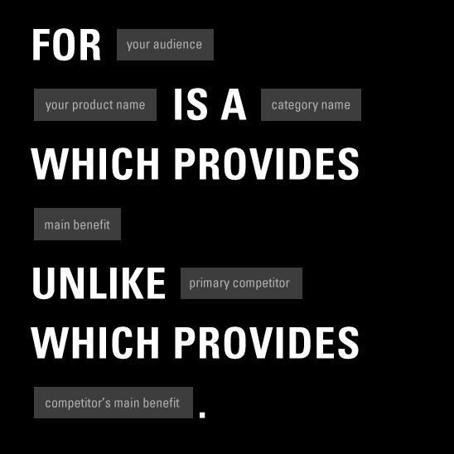

Template for Writing a Positioning Statement

Now it’s time to write your positioning statement up! Here’s a basic template (and another one) for writing a positioning statement:

For [Target Customer], the [insert Brand] is the [insert Point of Differentiation] among all [insert Frame of Reference] because [insert Reason to Believe].

- The point of differentiation (POD) describes how your brand or product benefits customers in ways that set you apart from your competitors.
- The frame of reference (FOR) is the segment or category in which your company competes.
- The reason to believe is just what it says. This is a statement providing compelling evidence and reasons why customers in your target market can have confidence in your differentiation claims.

Write down your positioning statement:

________________________________________________________________________________________________________________________________________________________________________________________________________________________________________________________________________________________________________________

Code 4: Using Mobile Features & Connecting to the Web

In this unit, you will...
- Make your phone interact with the world around you
- Connect your phone to the web
- Set up a mobile component and a database to use in your app

Key Terms and Concepts
User interface components - features that users can interact with  Media components - features that involve photographs, audio, and video  Sensors - parts of your phone that allow it to connect to the outside world  Social components - features that enable users to make phone calls, send emails, text and share things  Connectivity components - allow your app to connect to other places, such as the web and other apps. | Web databases - a database that stores data on the web so multiple phones can use it  Tag-value pair - a way to store data with two parts, a name and content  TinyWebDB - a web database that uses tag-pair values  Fusion tables - a database that uses tables to store and retrieve data  APIs - the way your app can talk to other websites to get information from them

Activities
Web Databases  Think of apps that use web databases | Time estimate  5 mins | Explore APIs  Think about how you could use an API in your app | Time estimate  5 mins

Code Challenge:
Time estimate: 2 hours
Choose one mobile component and either a web database or an API that you think would be useful in your app. Get both of these things set up and practice using them. Look up resources online to help you get set up. This will save you a lot of time when you build your final app!

Business Model

Revenue Model

A revenue model is a description or plan of how your business will earn money. Revenue is the money that a business raises from its normal business activities, usually from the sale of goods and services to customers. You will have profit once you subtract your costs from your revenue, which is the money you have earned and get to keep.

[Revenue] - [Operating Costs] = [Profit]

There are many ways to create revenue models, but for mobile apps, there are just a few options:

One-Time FeePaid App Downloads | In-App Purchases  (Including Subscriptions) | In-App Ads
Charge a one time fee to download an app providing a unique service. | Selling goods, services, or special features. Also known as ‘freemium’, which means it is free to download the free app, but a consumer pays subscription or extra fees to access special features. | Being paid through advertising, which can be through banner ads, pop-up ads (interstitial ads which are usually placed in between activities).
Examples
Minecraft  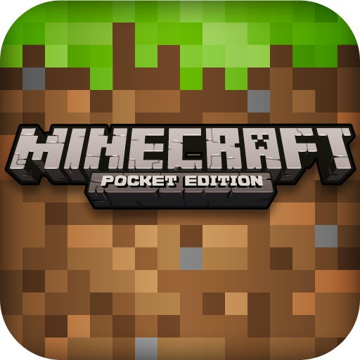 | Pokemon GO | Facebook

Food Cart Example

You would need to decide between one of the following options for how you would want to generate revenue for your food cart:

- Paid app model - sell each food item for a set price, and decide on the price
- In-app purchases - give away food, but sell condiments and larger plates at a set price
- In-app ads - give away free plates of food, but sell advertising space on the plates

Activity: Pick a Revenue Model

When developing your revenue model, you’ll also want to include the pricing of the things you are asking for.

How much is your app worth to your target customer (i.e. demand or appeal)?

How much is the ad space worth?

Do you have in-app purchases?

How much do competitors charge for their app?

Work with your team to decide what works best for your app.

Activity: Calculate Operating Costs

Now that you’re able to figure out how much money you could make using your revenue model, let’s think about how much it takes to get there. This is where we have to determine the cost of all the things that are needed to run or operate your business, which is called operating cost. There are many different kinds of costs that are involved. You’ll need to think about what costs you’ll have when you develop your app, which can include a variety of things that range from app store fees to a product you might sell through your app.

You might not need all the items listed and you can also try to cut some costs; for example your office space might be somewhere you can use for free.

Mobile App Development Component | Quantity & Cost
Equipment (computers, servers, networks)
Software (applications for development and testing, etc.)
Registration for Apple developers or Google developers
App store fees (for hosting)
Office space
Marketing/advertising
Employee salaries (developers, designers, etc)

Activity: Create A Business Model
Now it’s time to put together your startup capital, revenue model, and operating cost to develop a business model. As a reminder, use the equation below to calculate your profit:

[Revenue] - [Operating Costs] = [Profit]

Note: You don’t have all 5 years, but do at least a 3 year projection

 | Year 1 | Year 2 | Year 3 | Year 4 | Year 5
Startup Capital
Investors
Income / Revenue
Target consumer population
App cost
In-app purchases
Advertising sales
Operating Costs
Equipment (computers, servers, networks)
Software (applications for development and testing, etc.)
Service fees (databases, Amazon AWS)
Registration for Apple developers or Google developers
App store fees (for hosting)
Licensing fees
Marketing & advertising
Employee salaries (software developer, designer, etc)
Total Profit

You can always go back to the different sections and change things around. Remember, your business model is only a very well educated guess on how you think your business will operate financially.

Create Visuals and a Logo

Activity: Choose a Color
With your team, identify one of the colors in the chart above that best represents your brand's personality. For example, if you want people to identify your product as being exciting and new, you might choose orange as the color that best represents your brand!
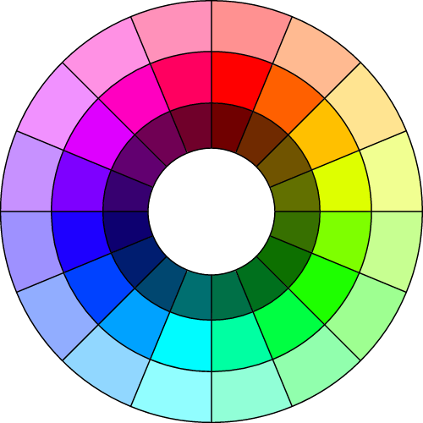

Activity - Choose a color scheme

With your teammates, choose a color scheme. Use the color that you chose in the last activity as your primary color, from which all other colors will be chosen on the color wheel. Remember to consider different tints and shades, and keep in mind the meaning of the colors as well as which ones look nice together!

Tip: Don’t worry about choosing a color that isn’t available in the presets in App Inventor. There will be instructions below on how to add new colors to App Inventor.

Stuck? Start with a photo! Find or take a photograph of something that helps identify your brand. It could be a location, an object, or anything else!

Activity: Create A Logo

Now that you've chosen colors and fonts for your brand, it's time to start creating your logo! A logo is a symbol that represents a company. A company’s logo aims to capture its goals, purpose, and personality all into a simple mixture of symbols and words. It sounds hard but let’s break it down into smaller pieces. There are three common types of logos:

Type | Example | Technovation Team Example
Word Mark |  | Loc8 don8 by team California Coders 2016
Symbol or Icon |  | Degreebee app by team CRException 2016
Combination |  | 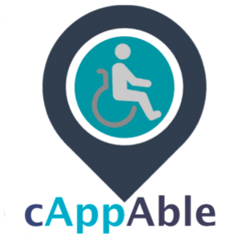  cAppAble by team X-Women in 2015

For this activity, each team member will need several small pieces of paper or index cards.

- Take some time to brainstorm some images that you think represent the problem you are trying to solve. Think about the people involved, the environment that is affected, and the solution you are proposing. Look at pictures on the internet as well as in books, magazines and anything else you have around you!
- Take 15 minutes for each team member to draw quick sketches in pen or pencil of what the logo might look like. The logo can be any of the types shown in the chart above (wordmark, icon, or combination). Try to make the sketches as quickly as possible, without pausing to think. Just draw and see what happens!
- After 15 minutes you and your teammates should have a large pile of sketches. If not, repeat step 1.
  - Together, look over the sketches. Choose a handful that are promising, or have qualities that could even be combined to create a stronger logo. Talk over these and sketch out 5 more logo ideas, this time more carefully and keeping in mind the way you want your logo to be used:Keep your logo simple. This will make it easy to discern at large and small sizes.
  - Think about how your logo will look on your app and where it will go.
  - Logos express an identity, so think about the things that define your business
  - Ask yourself, “What do I want people to think of when they see this logo?”
- Try designing 1 or more of the logos on the computer.

Once you are done, send your logo, color scheme and font choice to your mentor!

Create a Marketing Plan

Activity: Develop Marketing Goals

Work as a team to brainstorm goals you want to achieve. Consider what you will use to evaluate your goals. You will want also assign a value that you want to achieve and set a goal to achieve it within a certain amount of time. For example:

- At least 100 app downloads per month
- Getting at least 10 likes per post
- Reaching $100 in sales per week

Once you’ve brainstormed a few goal ideas, work together to narrow down to 2-3 goals in total.

1. ____________________________________________________________________________________________________
2. ____________________________________________________________________________________________________
3. ____________________________________________________________________________________________________

If you need any help, try asking a mentor! You should make sure your goals are realistic, so you are able to achieve them without making them so high that you’ll be discouraged if you are unable to reach them.

Activity: Define your Marketing strategy.

When it comes to marketing, there are many different types of strategies that you can use, but we will be sticking to the 4P’s: product, price, promotion, and place. We will tackle each section, and you'll likely notice where marketing and business work together.

Marketing Strategy (4 P’s) | Definition and your plan
Product | In this case, our product is very simple, it’s the app we are making!
Price | The amount the consumer is expected to pay for a product. This is not related to how you make money, but how you would price your apps to attract a customer.
Promotion | Here is where you want to make your app well known! Think about how you heard about the apps you use. Depending on the kind of app you develop, you can use different kinds of promotions to get more customers.  Here are some promotion strategies:  - Discounts- giving out coupons, freebies, or discounts to customers who use your product, usually used in the beginning to grow a customer base. A great option is buy-one-give-one.  - Media advertising - radio, online, print, or television that is used to promote to a large amount of people  - Social media - Facebook, Instagram, Twitter, Snapchat, or YouTube can be used to also promote to a large amount of people, and can be targeted to certain audiences.  - Google Adwords - paying for your product to po.p up when consumers search for certain keywords  - Viral media - making catchy videos or photos that gain name and brand recognition through social media  - Networking - Using your local connections to promote your app. You can also try using email too. Knowing an important figure or influencer to speak on the behalf of your app can be very helpful.
Place  (also known as Distribution) | This is based on where your customers will access your product. Since it’s a mobile app, you are generally restricted to the Google Play or Apple store. However, you can make your app look great in the virtual stores by writing a strong description, using keywords your customer will relate to, and helpful screenshots. Another way to add to your distribution is developing an online website to support your app.

Create a Pitch Story & Video

Activity: Build a Storyboard
A storyboard helps develop a strong argument for your app and makes sure you can tell a compelling story in order to convince potential investors to fund your app. It's a tool to help organize your story, just an outline for a long essay. This will help you organize your thoughts, develop your pitch deck and even your pitch video!

This activity will require your team to collaborate and brainstorm, so get a space you can work in together with a whiteboard, a large piece of paper, or several pieces of paper.

- First you’re going to brainstorm all your ideas in these categories:

- Core story - overview of the story you want to tell. It should be summarized in a short sentence or two

- Highlights - 3-5 strong selling points points about your business, so you can show off the cool functions or abilities of your app

- Hesitations - 3-5 items that investors might worry about if they were to invest in your business, and why your app is still the best solution

- Notes - any other things that will add to your story

Brain dump all of your thoughts! Write down all the knowledge you have about your app. Fill out the right side of the page as much as you can using the guidelines below. And don’t worry, you can always add to this part later.

- To start on your slides, you’ll write a title on top of each box. These slides will cover general topics, like the ones below described by Guy Kawaski, a marketing specialist and venture capitalist. You can always reorder the slides!

  - Problem - identify the issue and make it easy to understand
  - Your solution - demonstrate how you will solve the problem you highlighted (Hint: your app!)
  - Business model - explain how your business will make money
  - Underlying magic/technology - describe the features and functions of your app you developed
  - Marketing and sales - define who your customer is and how you will sell to them
  - Competition - show who are the people you are up against and how you are a better option
  - Team - showcase the people you work with
  - Projections and milestones - give an overview of what you’ve done, what you plan to do, and highlight major things you’ve accomplished
  - Status and timeline - report the latest updates and what you plan to do in the future
  - Summary and call to action - review of what you told everyone and what you want the audience do next

Core story encompasses all!

Flow
Flow
Slide message
Slide content
Story title

- Once you’re satisfied with the order of your slides, move on to draft each of the slide messages. This information will go at the bottom of the boxes. This is the main take away message you want the audience to know after they see this slide. If you need to move the slides around to make sure the flow of the story makes sense, go ahead and switch things up!

Core story encompasses all!

Flow
Flow
Slide message
Slide content
Story title

- Now you’ll want to add the content to the slides that will communicate your message clearly. When you develop these slides, remember that the end goal of this storyboarding will be a video. Your slides do not have to end up being just a pitch deck, your video can include skits, demonstrations, figures, or even interviews. This is where you can get creative in how you want you convey your message!

You also can draw rough diagrams or images of what figures you want to add. You want to tell the most concise story possible. By the end your slides should start filling up like the ones below:

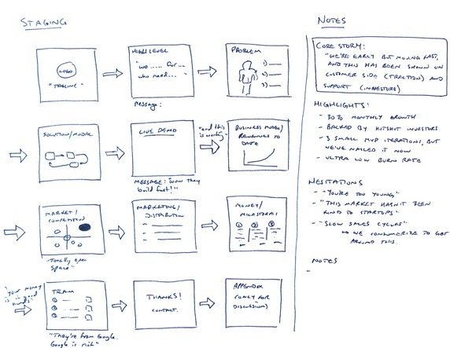

- Take a look at all the storyboard slides you created and make sure they are easy to understand for a wide audience. You’ll want to be self-critical— don’t keep anything that doesn’t add to your story or your slides’ message. Ask yourself:
  - Does it make sense?
  - How does it flow?
  - Is the core story being delivered?
  - Are the hesitations and highlights told in an elegant way?

Do the different ways of messaging tell the story in the best possible way?Ask a mentor or someone outside if your team to give you feedback on everything: your flow, the different ways are messaging information, and if it is telling the story you want. You’ll be presenting to a lot of people with different backgrounds, so asking people with different opinions can help you appeal to a wide audience. Remove anything that is unnecessary or extra.

UX Design and Paper Prototyping

Activity: Review Your Problem Statement and Create a Goal

Remember the problem statement your team worked on during ideation and brainstorming.

To summarize, the problem statement is a brief piece of writing that explains the problem that your team is addressing. It should outline the basic facts of the problem, explain why the problem matters, who it affects and how, and present a direct solution.

What you will need:

- Your initial problem statement.

What you will do:

- Review your problem statement, or work on it if you have not yet done so. It should answer four questions:

  - What is the problem? In design terms, this also translates to: what is the need
  - Who does the problem affect and how? This is important because the people who are affected by the problem will be the users of your app. They will be your stakeholders
  - Why is it important to solve? Why is this problem compelling and do you have any evidence of the problem to back up your argument?
  - What is the solution? You may have an initial idea for a solution. You will be experimenting more with the solution in this unit as you get to know your user and through paper prototyping!

- Now, can you condense your problem statement into one sentence that says what problem you app is trying to address and how it will address it? This will be used as your goal moving forward.

Write down your problem statement:

________________________________________________________________________________________________________________________________________________________________________________________________________________________________________________________________________________________________________________

Activity: Make a Map of Your Stakeholders

What you will need:
- Post-its
- Markers

What you will do:
- Brainstorm and write down all the possible stakeholders for your project - one per post-it
- Cluster the stakeholders into similar groups, such as “adults”, “kids”, “school staff”
- Decide which stakeholders you will focus on for your app
- Write down questions you want to ask them
- Plan interviews with stakeholders - individuals on your team can interview people separately to save time, or you can go together if that is more comfortable for you
.
Once you have clarified your goal and have identified the stakeholders you would like to interview, you will be ready to learn more about how they think.

Activity: Conduct Stakeholder Interviews, Gather Personas and User Stories

To find out what stakeholders want the app to do, you will need to interview them. You can ask them questions to help you find some functional requirements of your app. Functional requirements are things the app needs to do.

Interview a set of people who are potential stakeholders of your app to learn more about the problem and get their thoughts about the solution. If you know of apps that already exist to help solve the problem your team is focusing on, you can ask users about the app and what they like about it or what doesn’t work so well for them.

What you will need:
- The questions you wrote down in the stakeholder map activity
- Paper
- Something to write with
- Voice recorder or app if you want to record the interview

What you will do:
- Introduce yourself and give the person you are interviewing a short overview of what your project is about. Why are you interested in receiving her or his feedback?
- Ask the questions your team prepared

1

Step 1: Identify the User Persona for the person you are interviewing. A persona is a description of a prototypical person (real or fictitious) who will be using the app. A persona lets you design with a specific user in mind, rather than designing for ‘everybody.’ Create as many personas as you need to capture the main categories of people who will be using the app.
 | Name
 | Occupation
 | Age
 | Gender
 | Technical Comfort
 | Other Relevant Demographics
Background
Goals | Needs | Pain Points

Step 2: Go a little deeper into what functions your user would like the app to have and why using a User Story Template

As a <User Role> | I want to  <Action/Goal> | So that <Value>

- Come back together as a team and share your experiences from the interview process, along with your personas and user story templates.
- If there are any more stakeholders you feel you need to interview in order to get the information, do this now before moving on to the next step, which is design! You will soon create a paper prototype, which is a fun and creative process.

Activity: Create Paper Prototype of Your App

What you will need:
- Markers
- Optional:
  - Stickers
  - Glue
  - Scissors
  - Tape
  - Magazines

What you will do:
- As a team, sketch each screen of your app. Put your ideas down as they come and try not to judge them yet. You can question them later! As you do this, you may want to consider:
  - What would the first screen look like?
    - Will it have a logo? (Hint: Take a look at your favorite apps for inspiration)
    - What is the color scheme going to be?
  - What happens if you click on a button to get to the next screen?
  - What will each screen look like?
  - How will the user navigate the different screens?
  - Can you show with arrows how this would happen?
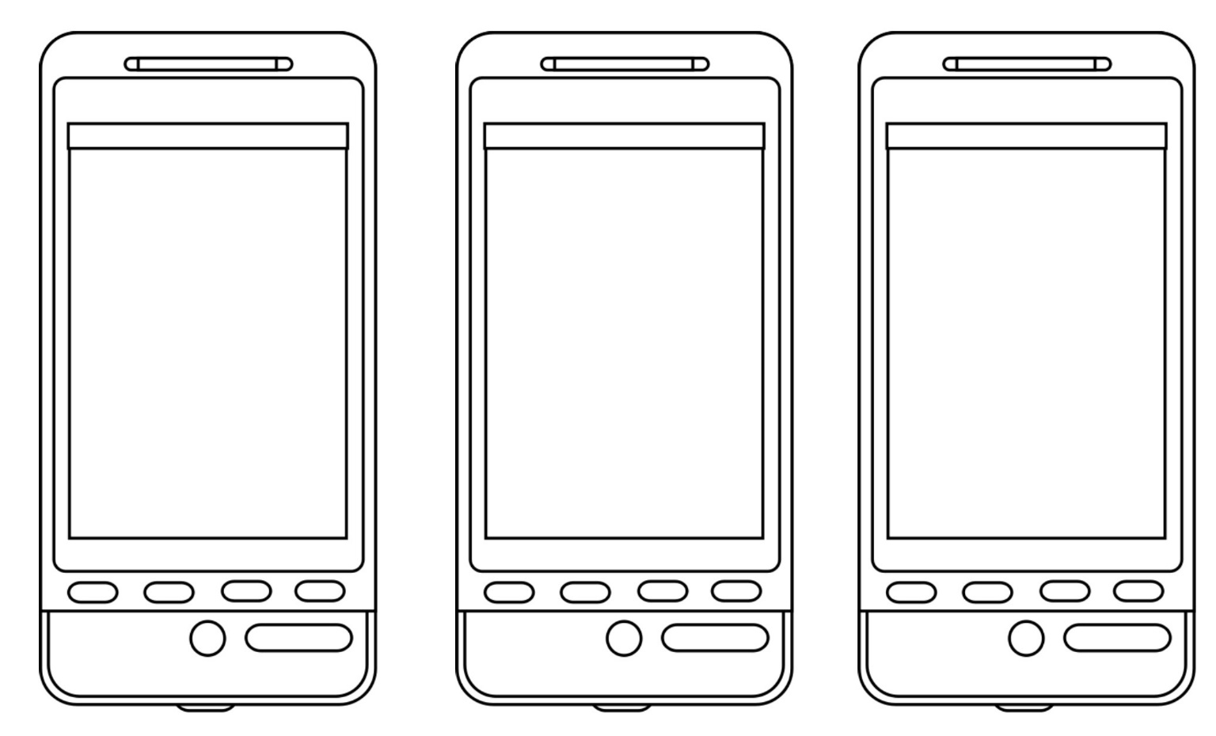
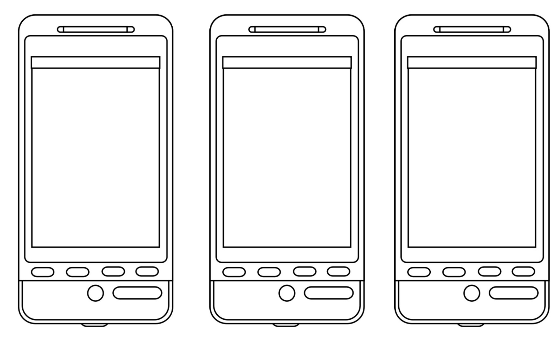

Activity: Test your Prototype and Collect User Feedback

Now that you have a paper prototype, it’s time to share it for feedback! Remember the stakeholders who you interviewed? You will find out if the app meets their needs and expectations.

What you will need:
- Your sketches
- A camera, laptop, or phone which can shoot video

What you will do:
- Rehearse! Run through different scenarios before you meet with your stakeholders, and practice the presentation of your prototype. Refine it if you think it can be better.
- If you want to create a video demo, you can do that instead. It might be good practice for the demo video you will create later to submit to the Technovation Challenge!
- Check in with your mentor and share what you plan to show your stakeholders. Ask for feedback and incorporate it
- Bring either your paper prototype or your video to your stakeholders, and ask them for their feedback. What worked well, what can be improved in their view?
- Ask them questions that are in the User Testing Worksheet - for example, was anything was unclear in the user interface, and what features have the highest value? Write down the responses.
- A reminder to be gracious when receiving any feedback, including negative feedback. This is your chance to make your app better! If you have clarifying questions, you can ask them. Keep in mind that their feedback is about the app, and not about you personally!
- Send a thank you note to your testers and let them know you would be interested in meeting up with them again to test your digital prototype when it is ready
- Consider asking your peers and your mentor to complete the User Testing Worksheet as well!

User Testing Worksheet

Take notes on the feedback you receive here. Answer the Usability Testing questions and add some of your own before you begin if needed. Consider asking your peers (or mentor) to complete the table below as well. Use this feedback before you start work on your digital prototype.

Questions | Notes | Changes that need to be made by the team
Is there anything that is unclear or confusing in the user-interface?
Would you prefer the app look or behave differently?
Which features of the app interface and usability are of highest value?
Are there any missing buttons or other content from the app?
Did your expectations differ from the intent of the app?

Business Plan Checklist

This module is not mandatory for Junior Division, but Junior teams who want to learn more about building a business are encouraged to follow along. Only Senior Division teams are required to submit a business plan.

- Title page. 1 page
  - Team name (or business name)
  - Team member names
  - Product (mobile app) name
- Table of contents. 1 page
  - Section titles and page numbers

- Executive summary. 1-2 pages
  - Your business name and location
  - The products and/or services offered
  - The purpose of your plan (to secure investors, launch an app, etc)

- Company description. 3-4 pages
  - The kind of business you are (corporation, social enterprise, nonprofit, etc.)
  - Your company's mission statement
  - The important people in your business and the roles they play
  - An overview of what you plan to sell and who your market will be
  - A brief history of how your business was created
  - Outline what you want to accomplish in the immediate future based on the information in the rest of the business plan and your future goals

- Products and/or service description. 1-2 pages
  - In-depth description of your products/services, emphasizing the specific benefits to the customer
  - An explanation of how your product/service has advantages over the competition
  - Product development:
    - Current stage of development product (how ready is it to be given to the customer)
    - Information about how the product will be built and sent to the customer
  - Research and development activities that may lead to new products and services

- Market analysis. 3-4 pages
  - Description of the market:
    - Who are the key competitors?
    - How you think your mobile app will perform and why?
  - Customer research: A sketch of your customers, including size and demographics
  - Competitor analysis: a detailed evaluation, highlighting their strengths and weaknesses
- Marketing Plan (strategy & implementation). 1-2 pages
  - An explanation of how you will reach target customers and enter the market
  - Details about pricing, promotions, and distribution of the app
  - An explanation of how the company will function, from when the app is produced to when the app is delivered to the customer
  - Information on number and types of employees you have or will need

- Financial plan & projections. 1-2 pages
  - How much money you have now and how will you be using it
  - How much money you’ll need and what goals you have set for them
  - How much money do you plan to make in the next 3-5 years and how (profit projection)

Additional components:
- Page numbers
- Appropriate branding
- Charts and figures are clearly labeled and easy to understand
- Images are included in the document when necessary
- Plan is in PDF format
- Bibliography/citation page for your references

Submission Guidelines
Here are the requirements for you to get the maximum number of points.

Pitch Video  - Must be 3-4 minutes  - Must be in English or include English subtitles  - It is recommended that all team members speak  - Share with a youtube or vimeo link * | Demo Video  - Must be 1-2 minutes  - Must be in English or include English subtitles  - Share with a youtube or vimeo link * | Business Plan (senior division only)  - Must be a PDF  - Must include everything listed in the Business Plan Checklist  - Share via a google drive link, dropbox link, or upload directly to our site *
Team photo and summary  - Write a paragraph to help people get to know you | App Name & Description  - 100 word maximum app description | Screenshots  - Upload at least two screenshots of your app
Source Code  - App Inventor, Java, Objective-C, Swift, C#, or any other programming language files are accepted  - If developed in App Inventor, here are instructions on how to export an .aia file (not .apk)  - Share via a google drive link, dropbox link, github link, or a direct upload of a zip/compressed file containing your source code * | Code Checklist (This will not appear on your public submission page)  - Fill out fields with short sentences or pictures to earn up to 10 points  - Read the full code checklist here: Code Checklist | Pitch Presentation (only if attending a pitch event)  - Must be a PDF, PPT, or Google slides  - Share via a google drive link, dropbox link, or upload directly to our site *  - This is not due on April 25th, the due date will depend on the event you are attending

* Important: All youtube videos and google drive/dropbox links must be shared publicly in order for judges to see your submission. Please double check your links.

Judging Rubric
